Nexora tasks and notifications
Document 17 of the Nexora learning guides
Source snapshot 13 October 2026 at 17:12 UTC
Understand work items, assignees, teams, completion and staff notifications.

Recognise the screen and its scope
Open /work/items, /work/notifications. CRM routes use port 3017; member routes use 3018; public website routes can use 3019. Brackets name a route parameter, not text to paste into a browser. Choose a real record or site id from the application.
This guide covers Task creation and priority; User and team assignment; Due dates; Complete task; Notification lists and read state; Task export.
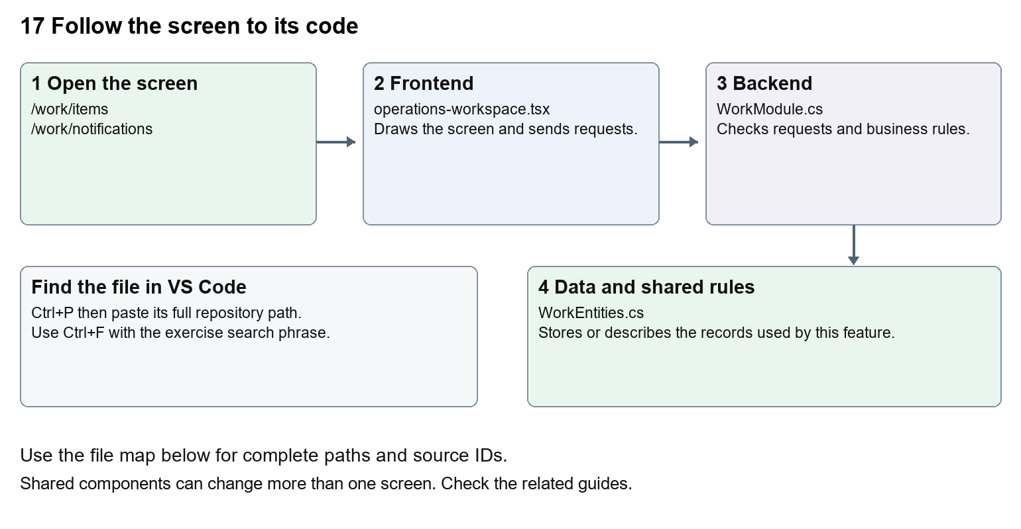
The diagram shows the file roles. The full paths below are what you paste into Ctrl+P.

Find the files in VS Code
Role | File and source ID | What it does
Screen | S0118 operations-workspace.tsx | Main UI or route for this topic
Server | S0538 WorkModule.cs | Endpoints or server rules
Data | S0520 WorkEntities.cs | Data shape or persistence structure

Screen S0118
apps/web/src/features/operations/operations-workspace.tsx
Server S0538
backend/src/Modules/Nexora.Modules.Work/WorkModule.cs
Data S0520
backend/src/Modules/Nexora.Modules.Work/Domain/WorkEntities.cs
The complete HTML manual opens these source IDs inside its Source library. The Word manual shows short labelled extracts so you can learn the flow before reading large files. Each individual Markdown guide includes its complete primary files after the walkthrough.

Follow the request and the records
1. The Work route chooses items or notifications.
2. OperationsWorkspace loads records through moduleApi.
3. Task creation sends the fields described in the work actions array.
4. Completing sends a patch with its current version and updated status.
5. The server persists task or notification changes for the current tenant.

Read the code with an explanation
A task is a stored item with title, priority, status and optional due date and assignee. Staff notifications are separate from the Member Portal inbox. The shared operation form converts number and date fields before it sends JSON. A date label change is safe; changing conversion logic can change stored times.
Source reference S0118 apps/web/src/features/operations/operations-workspace.tsx
Selected opening lines with their original numbers. The complete file is in the HTML source library.
0001 "use client";
0002 import listingStyles from "../crm/record-listing.module.css";
0003 import { WorkspaceHeading } from "@/components/ui/workspace-heading";
0004 import { RecordListing, useRecordPage } from "../shared/record-listing";
0005 import { Plus, ArrowLeft } from "lucide-react";
0006 import { useEntityListing } from "../shared/entity-listing-controls";

The import lines lead to shared components and helpers. Start at the exported component or route function; follow the request helper to the server rather than assuming the whole feature lives in this file.
Source reference S0538 backend/src/Modules/Nexora.Modules.Work/WorkModule.cs
Extract from source line 25. A fragment from a long line is shown without the rest of that line.
0025 ork.manage", typeof(WorkItem));api.MapGet("/directory",(IIdentityDirectory directory,C

On the server, look for MapGet to load records, MapPost to create or perform an action, MapPut or MapPatch to change data, and RequireAuthorization for permissions. Some shared methods register endpoints indirectly. Find SaveChangesAsync to see the database write. A request method alone does not tell you every side effect.
Source reference S0520 backend/src/Modules/Nexora.Modules.Work/Domain/WorkEntities.cs
Selected opening lines with their original numbers. The complete file is in the HTML source library.
0001 using Nexora.BuildingBlocks.Domain;
0002 namespace Nexora.Modules.Work.Domain;

Follow model fields to their request names and database mapping. An id points to a particular record. A tenant id limits the organisation. A version or concurrency stamp protects newer edits. Some model files describe contracts rather than tables; check the owning DbContext before assuming storage.

Make or trace your first change
1. Press Ctrl+P and open apps/web/src/features/operations/operations-workspace.tsx.
2. Press Ctrl+F and search for Show assignees and teams. In this snapshot it appears at line 28.
3. Replace this Work-only button label. Open task creation and verify the directory still loads. Inspect Engagement because it shares the component.
4. Replace only Show assignees and teams with Find staff and teams in that intended location. Keep quotes, tags, JSON keys and routes intact.
5. Save with Ctrl+S. Inspect Problems and the local screen. Review the diff and restore the original text when you finish practising.
Extract from source line 28. A fragment from a long line is shown without the rest of that line.
0028 ectory(results);return results;})}>Show assignees and teams</button>}<p className="text-sm text-slate-50

These exercises have not been applied to the application. Their search phrases are verified against the captured source. Line numbers can move; the phrase and file path are your main navigation aids.

Check a change and diagnose problems
Confirm the original screen still loads, the changed words appear in the intended place, and another screen using the same component still behaves correctly. If an action fails, inspect the browser Network response, the relevant helper and server validation message. Use the common error table at the beginning of the manual. Reload on a version conflict instead of removing the version check.
A syntax error after a text edit usually means a quote, brace or closing tag changed. Compare your diff with the original. An unchanged browser result can mean the wrong port, a saved published configuration overriding a default, or a running API that has not reloaded.

Understand the current limits
Marking an item done or a notification read changes persistent records. A listed notification is not proof of a push or email provider delivery.

Continue learning
Related guides 16 Nexora engagement and fundraising, 18 Nexora imports exports and migration, 20 Nexora administration and access, 25 Nexora member portal journeys.

